
COURSE UNIT: IST 1104
LECTURER: MALE VINCENT
ASSIGNMENT FOR COMPUTER NETWORKS BY GROUP1.
GROUP1 MEMBERS:
1 .ACHUDA FREDRICK 26/U/29544/PSA
2. ABOKU GEORGE PHILIP 26/U/03678/PSA
3. WAMANGA SHAMIHA 26/U/04227/PS
4. AINEBYONA VICTOR 26/U/03692/PSA
5. AKAMPURIRA IAN 26/U/03698/PS

SOLUTIONS
NO.1
A computer network is a collection of two or more computers and other devices that are connected together to share data, files, software and communicate with each other. For example laptops, scanners, printers, smart phones and etc connected together.
Network =Nodes + links.

NO.2
computer networks have done a great job in countries link uganda mainly through ;
Resource sharing; through the use peripheral devices like scanners, printers and many others to share emails, files and many others hence making the resource available to anyone on a network without a regard to the physical location of the resource and the user.
Eases communication; where information is stored on servers and accessed by authorized users from different computers in an organization. For example networks support video calls, online meetings and voice calls.
Data storage and management; this makes it easier to store, access, share, protect and organize information within the organisation.
Eases administration of application softwares; through the process of installing, configuring, updating and securing software programs and operating systems that run on network servers, workstations and commutation devices to keep the network safe and reliable.
Highly reliable; this gives alternative sources of supply for example all files can be replicated on two or three machines, so if one them is unavailable the other copies be available.
Reduced costs; the goal of computer network is to save money letting users share expensive hardware, software and data instead of buying separate items for everyone.
Sharing single internet connection; its cost effective and efficient since all users are connected to one internet bandwidth.
Reduces error and improves consistency; since all staffs work from a single point of information for example making standard versions of manuals and directories in an organisation.

However,computer networks have also have bad impacts ;
Security risks; unauthorised personnel may gain access to sensitive information which can be manipulated by hackers
Slow performance; due to network overload
Requires skilled personnel to manage and operate complex equipment.
Server dependence ; if the server fails the entire network is down affecting productivity
Virus spreading; a single infected file can corrupt the whole network
High set up and installation costs; buying cables and other network equipment is expensive.
Maintenance costs; computer networks and equipment are expensive to maintain for example upgrading softwares and hardware equipment.
Misinformation; false information can be easily spread on the computer networks.

NO.3
Personal Area Network (PAN); It is a short range personal device to device connection within a range of 10m. For example Bluetooth, mobile hot-spots
Local Area Network (LAN); it connects devices around a small geographical area. For example school Wi-Fi, school computer labs, office buildings and many others.
Metropolitan Area Network (MAN); This covers a metropolitan area (city or town) for example local government offices, campuses.
Wide Area Network (WAN); It covers a very large geographical area like a country or continent for example internet
Campus Area Network (CAN); This joins multiple local area networks together.
Other specialized computer networks include;
Wireless Local Area Network (WLAN): This is a LAN without cords or cables. For example Home Wi-Fi.
Storage Area Network (SAN): Links servers to the data storage devices. For example Data centres.
Virtual Private Network(VPN): Extends a private network across a public network like internet.
Enterprise Private Network (EPN): This is a private in-house network for big organisations.
Peer to Peer Network (P2P): Is where devices communicate or talk directly with each other. For example file sharing between Laptops, gaming networks.

NO.4
The Network Topology is the physical and Logical arrangement of nodes and connections in a computer network which govern how data flows between devices.
The Different Types of Network Topologies include the following below:

Bus Topology:
Is a type of network topology where every device is connected to a central cable called the Bus or backbone. If the main cable breaks, the entire network goes down.
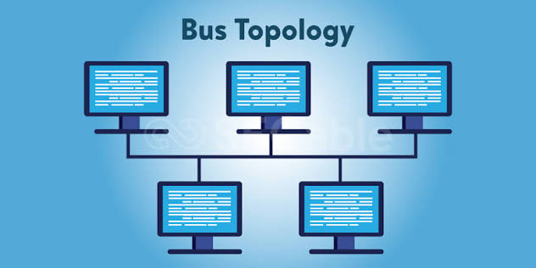
Ring Topology:
Devices connect in a circle. Data travels in one direction and if one device fails, the ring breaks down.
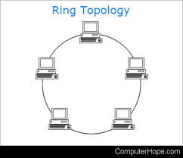
Star Topology:
All devices plug into a central hub or switch. If one cable breaks, only that device looses connection. Failure of the central hub also leads to the break down.


Tree Topology:
Devices form groups in a branching hierarchical shape that mixes a star and bus styles.
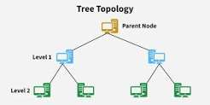

Mesh Topology:
Every device connects to many all other devices. It is very reliable because data has backup paths, but it costs more.
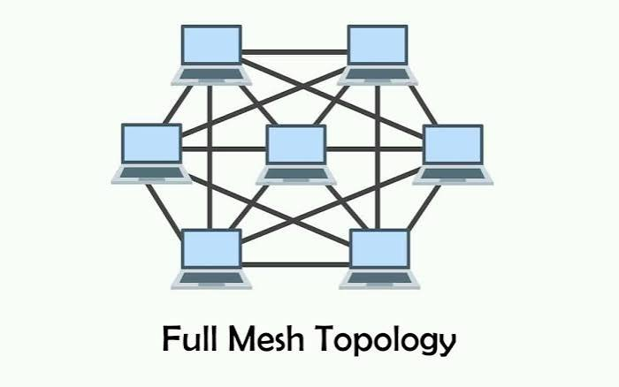

Hybrid Topology:
Is a mix of two or more different topologies like blending a star and a ring network.
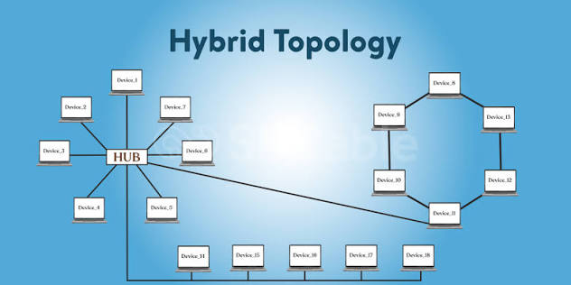

Point to Point Topology:
It has a single wire that links two end points.
